# Overview

The following describes a process to laser cleaning the carousel part. It can be generalized to handle other parts. Some details on the exact laser settings for feedrate, power and number of passes is likely to change but the basic flow should be useable.

The primary challenge is achieving submillimeter accuracy on a laser engraver. Engraver software is designed to be very accurate for positions within an image but is relatively inaccurate in the starting position and rotation of the image. So the Images are beautifully rendered but the exact location on the part is not critical.

In the case of the Carousel part, the absolution position on the part is critical for successful cleaning of the masking resin from the pads. The process outlined significantly improves the absolute positional accuracy, however, the tolerances will be at the edge of what a human operator can achieve by eye sight alone. Further improvements may be required.

# History

10/4/25 first draft

Overview 1

History 1

Overall Process 2

Initial Setup Steps 2

DXF File 2

Generating the Ideal G-Code 4

Steps Performed on Each Part 10

Calibrating the laser to the part 10

Adjusting the G-Code 11

Cleaning 11

# Overall Process

# Initial Setup Steps

## DXF File

Using a CAD program like Fusion 360 or Shapr3d create a sketch with the paths the laser should follow. These can be lines, arcs, circles, polygons, etc.

In Shapr3d, you can have construction elements that help position elements but will not appear in the DXF output. This is useful for precise positioning.

The following instructions are for Shapr3d, other CAD programs will have similar capability.

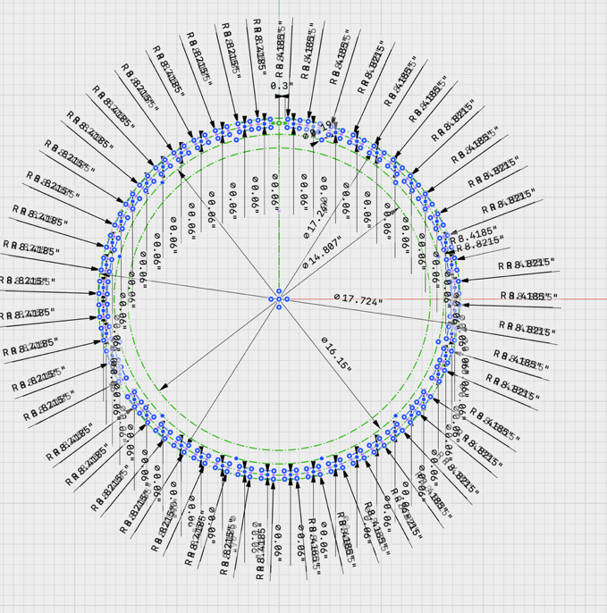For the Carousel, the pads were drawn first from the CAD drawing. From a top down view a sketch is created on the XY plane with the outer and inner grooves were drawn using circles centered on the origin.

Then an ideal pad was created at zero degrees along the X axis. The ideal pad has a center post defined as a construction circle, so it will not appear in the laser path. It is offset from the origin along the X axis. Then two parallel horizontal lines are created at +/-0.3” from the post center. The outer and inner circles are clipped so just the polygon of the ideal pad remains.

This ideal pad is then rotated around the origin (0,0) in the XY plane to create the 48 pads at the appropriate angles.

The result is a single sketch that looks like this:

Zooming in shows the pad elements and the construction elements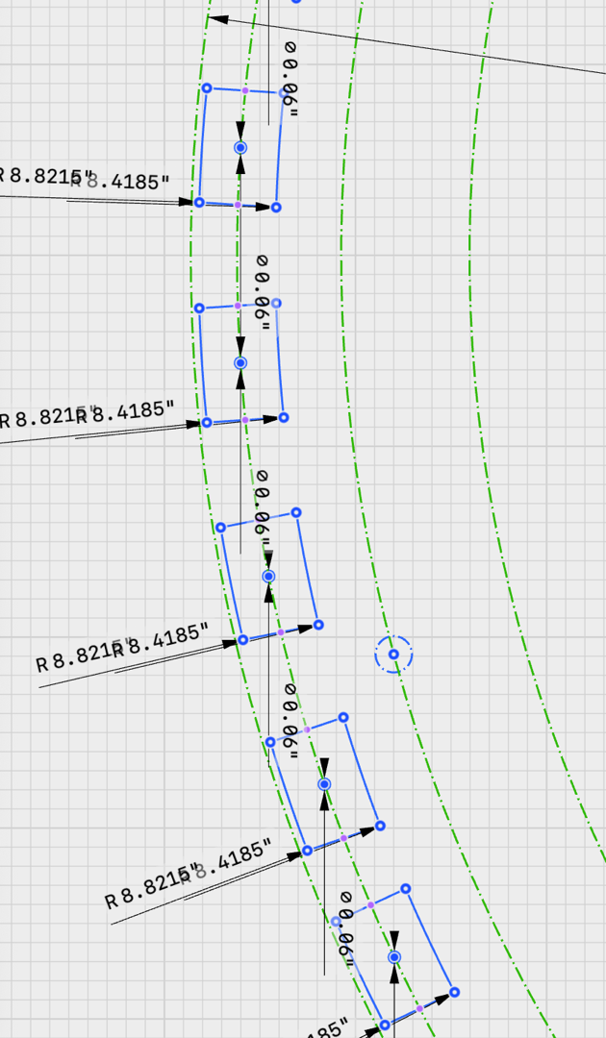

From this sketch we also capture two key coordinate that will be used in the calibration process later.

To align the laser to the actual position of the carousel on the laser table submillimeter precision is needed. Because the worktable, laser and workpiece all have offsets and rotations relative to each other, the two points are used to adjust the ideal g code to translate and rotate the points in a later step.

The carousel is bigger than the laser’s worktable in the y axis so the carousel will be cleaned in two passes, shifting the carousel down for one pass and up for the second pass. The two points are chosen to always be accessible on the worktable.

The points are also chosen to be far apart to increase the accuracy of the measured translation and rotation.



From this CAD sketch a second file is created. For each pad the offset too is used to create the paths for the laser cleaning. In this case, two cleaning paths were chose for a beam width of 0.4mm (slightly defocused). The first pass is offset 0.2mm and the second pass is 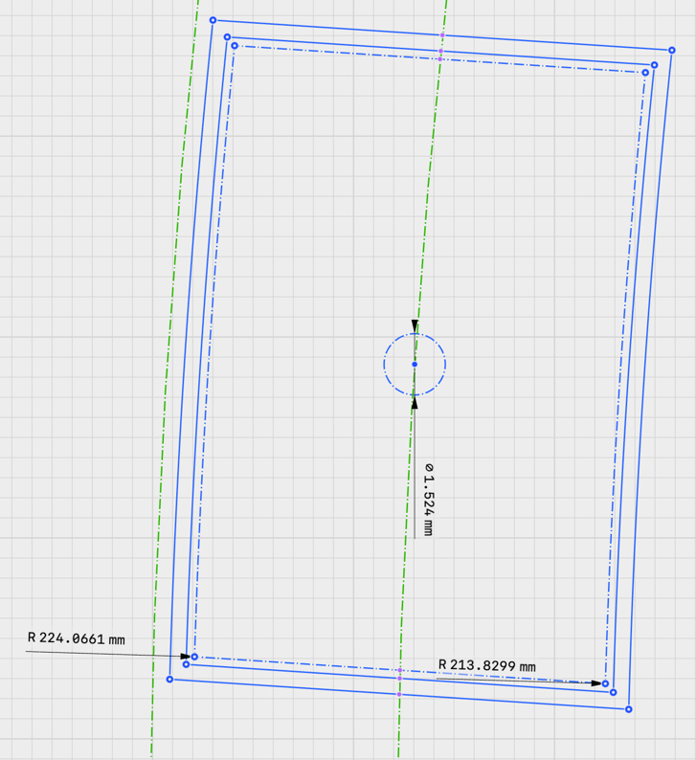offset 0.6mm to give a 0.8mm cleaning area around the pad.

All elements other than the clean paths are turned into construction elements. The resulting CAD sketch looks like this for a pad. The dashed lines show the construction elements of the pad and the center post. The solid lines and arcs show the the laser path.

This file is then exported from the CAD tool. In Shapr3d, this is done as a DXF file from sketch. The resulting DXF file is in ASCII format and contains all the solid elements coordinates.

## Generating the Ideal G-Code

A python program is used to create the ideal G-Code for cleaning the carousel. This process reads the DXF file and allows the user to select what elements G-Code should be generated for. It also allows the part to be positioned on the worktable and laser cutting parameters set.

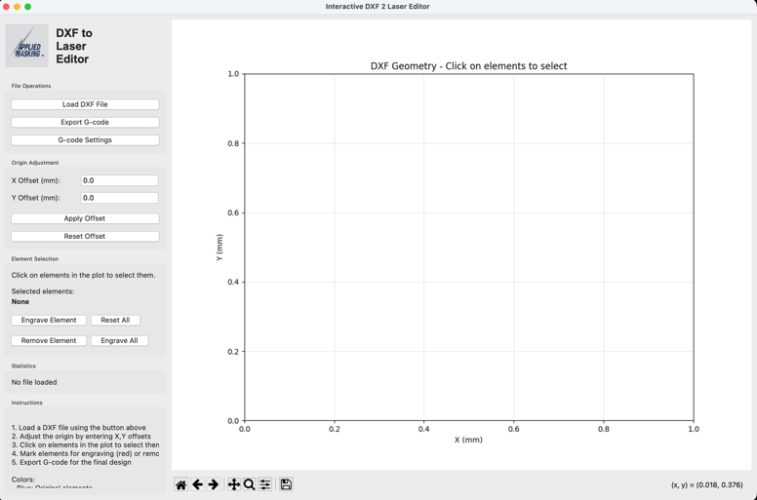The first step is to launch the python program from VScode and go to the G-Code settings display.

Adjust the parameters to these settings:

|  |  |
| --- | --- |
| **G Code Wrapper** | |
| G-code Preamble | G21 ; use mm units  G90 ; use absolute positioning  G54 ; use work coordinates  G0 X0 Y0 Z-74.9 ; go to starting position |
| G-code Postscript | M5 ; turn laser off  G0 Z-3 ; move laser up for safety  G0 X-250 Y100 ; move laser out of the way |
| **Laser Settings** | |
| Laser Power | 5500 |
| Cutting Z Height (mm) | -74.9 |
| Feedrate (mm/min) | 2800 |
| **Coordinate System** | |
| MPos Home X mm | -797.0 sets lower left hand corner X, Y, Z position |
| MPos Home Y mm | -397.0 |
| MPos Home Z mm | -3.0 |
| **Max Travel** |  |
| MPos Home X mm | 794.0 max travel from home position in x, y, z |
| MPos Home Y mm | 394.0 |
| MPos Home Z mm | -92.0 |
| **Wpos Home in mm** |  |
| WPos Home X mm | -400.0 WPos home in MPos coordinates for X and Y |
| WPos Home Y mm | -200.0 |
| WPos Home Z mm | -3.0 Note that Z MPos = WPos |

These values can be saved to a file and reloaded to avoid typing in each time. The file format is a simple JSON file.

{

"preamble": "G21 ; Set units to millimeters\nG90 ; Absolute positioning\nG54 ; Use work coordinate system\nG0 X0, Y0, Z-74.9 ; Go to zero position\nM4 S0 ; laser on at zero power\n",

"postscript": "M5 ; Turn off laser\nG0 Z-3 ; Raise Z\nG0 X-250 Y100 ; Send to unload position\n",

"laser_power": 5500,

"cutting_z": -74.9,

"feedrate": 2800,

"mpos_home_x": -797.0,

"mpos_home_y": -397.0,

"mpos_home_z": -3.0,

"max_travel_x": 794.0,

"max_travel_y": 394.0,

"max_travel_z": -92.0,

"wpos_home_x": -400.0,

"wpos_home_y": -200.0,

"wpos_home_z": -3.0,

"raise_laser_between_paths": false,

"optimize_toolpath": true

}

Then load the DXF file and you should see the following:

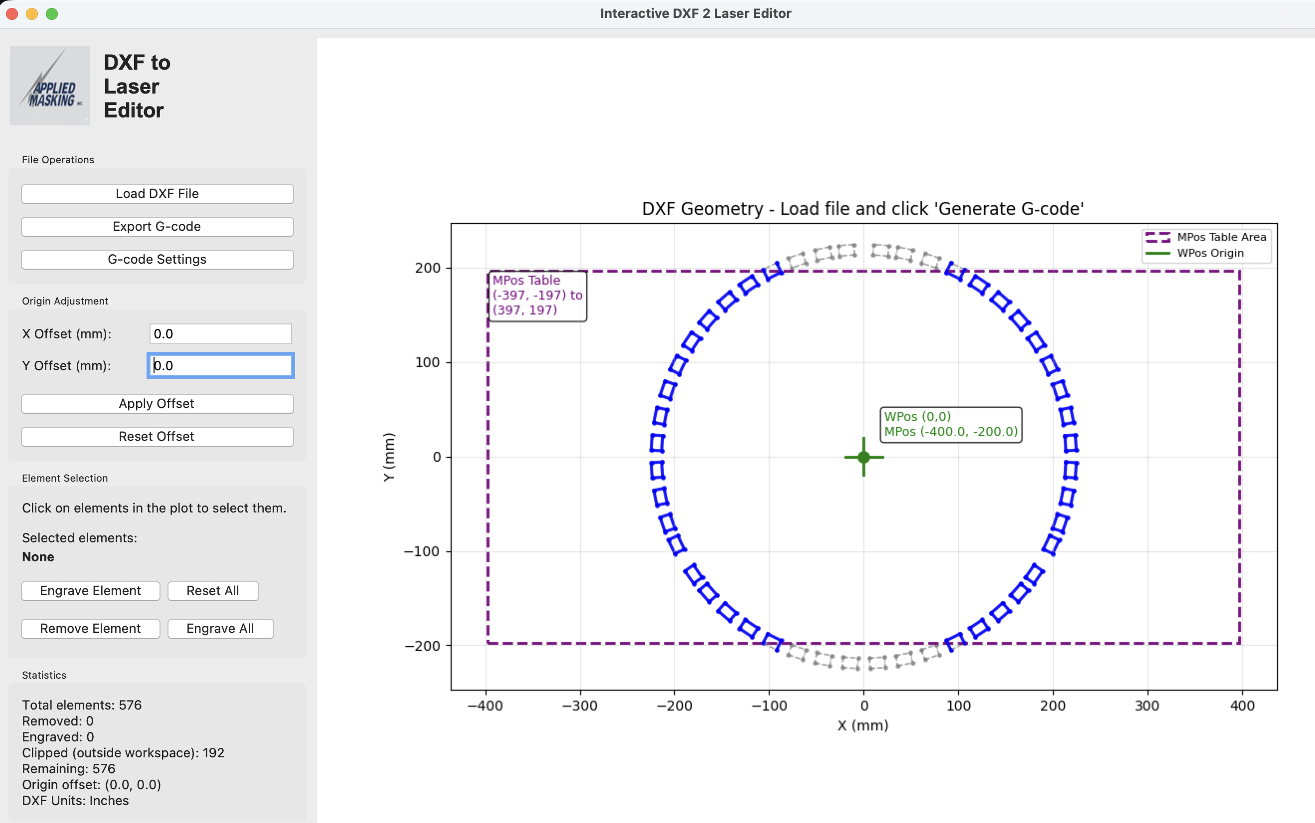

The next step is to create two G-Code files. One with the laser paths shifted down so the upper section can be cleaned and then shifted up so the bottom section can be cleaned.

Apply a Y Offset of -50mm and the display will show this

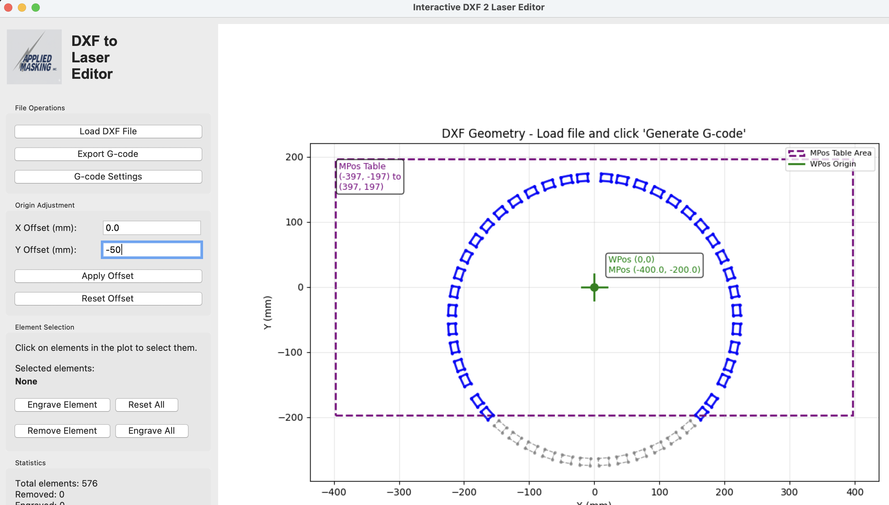

Then use the mouse in the DXF geometry window to select the pads for section 1 and 3 as shown. They will high light as green, then select engrave element and they will turn red. These are now the elements that laser path g-code will be created for. Here are the series of pictures:

1. Select the elements using the mouse click and drag the yellow highlighted area over the elements.

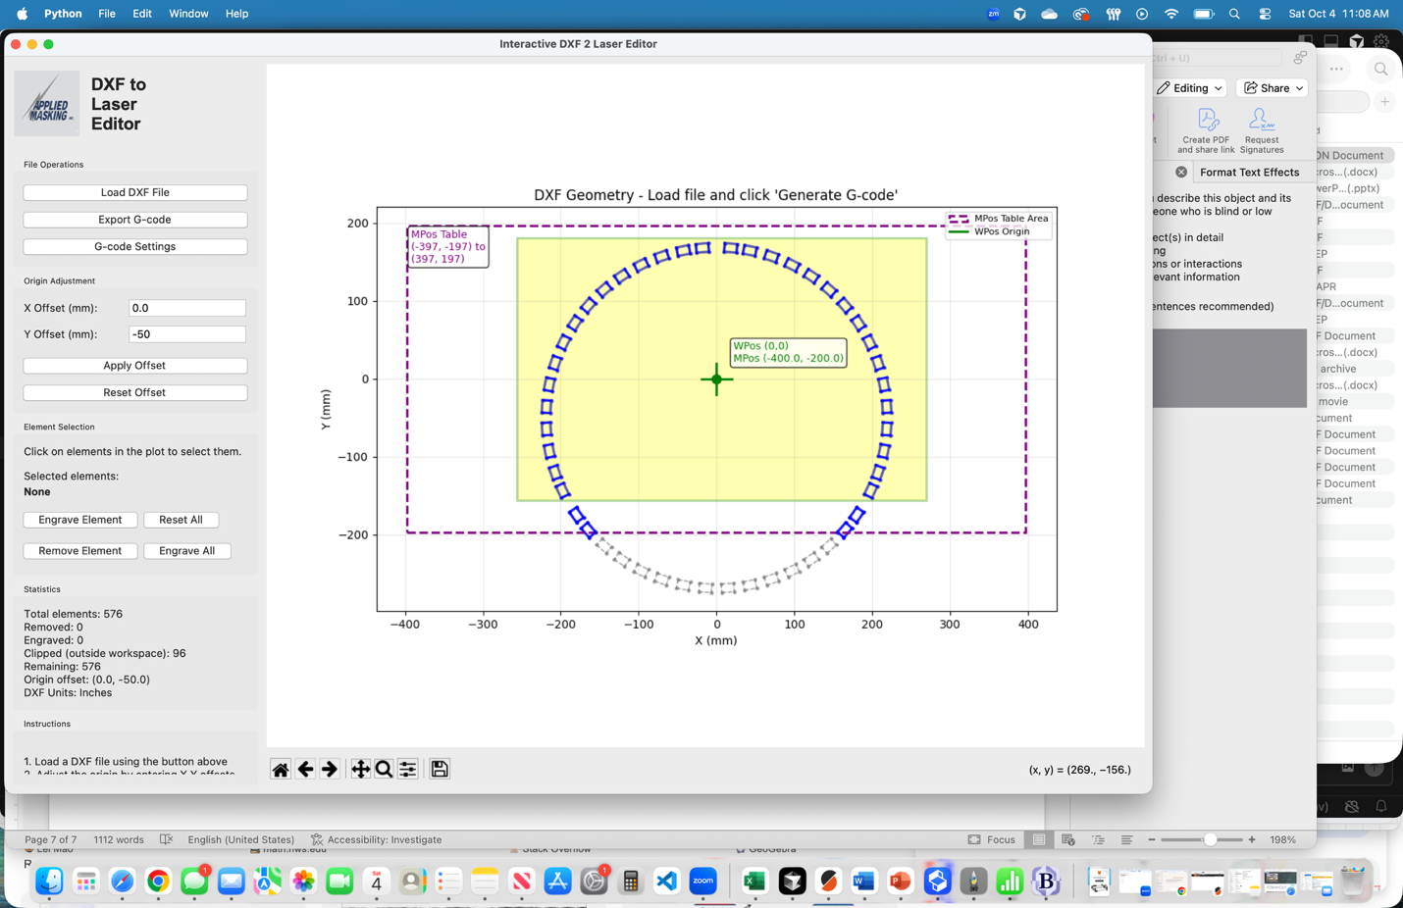

1. The selected items will turn green, showing they are selected.

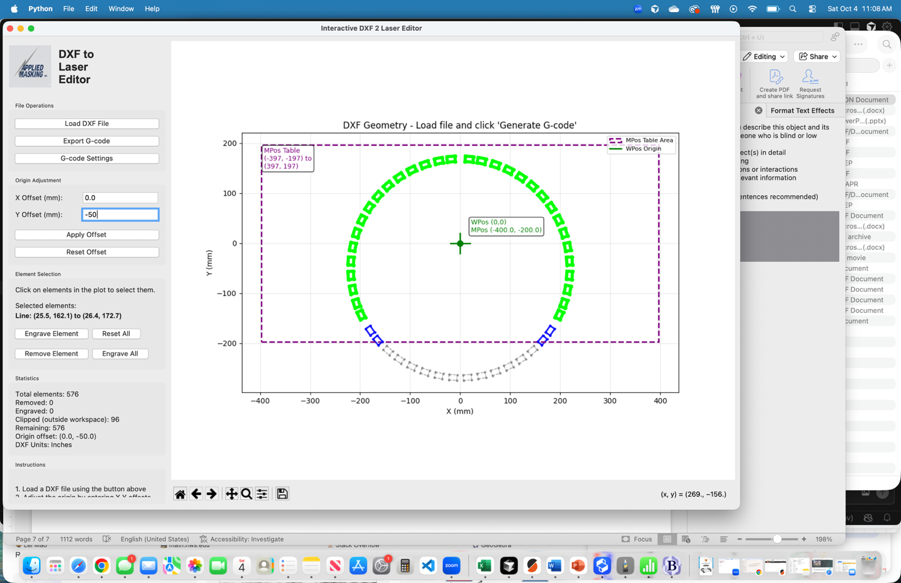

1. The click the “Engrave Element” button and they will turn red showing g code will be generated for these elements. Notice four elements were not selected, these will be done in the second pass. Also note the element off the work table are shown in gray.

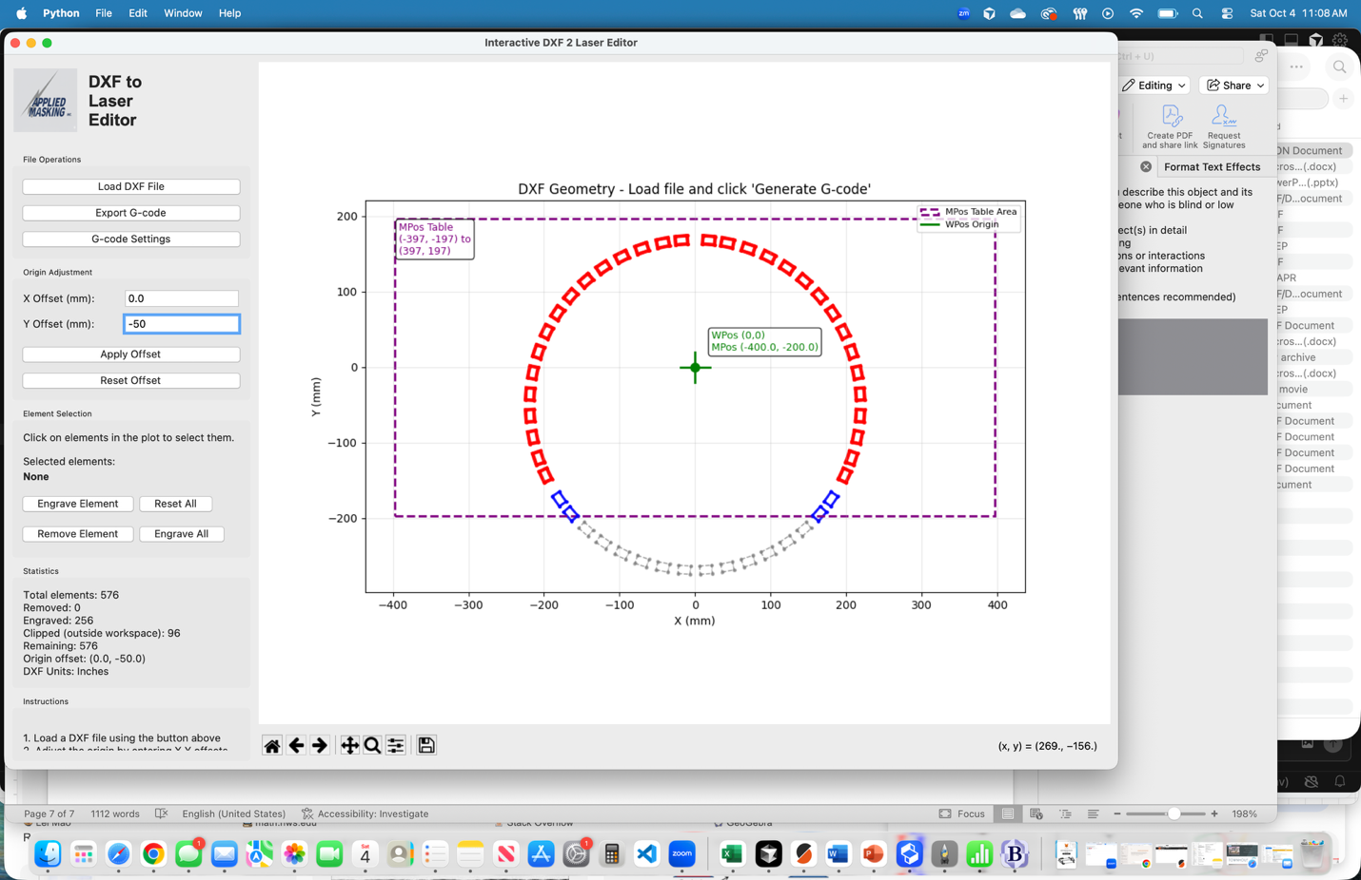

Now click the “Export G-code” button and this picture below will show up. This shows the path the laser will take. It assumes the laser starts at the origin but in reality it will work from any laser starting point.

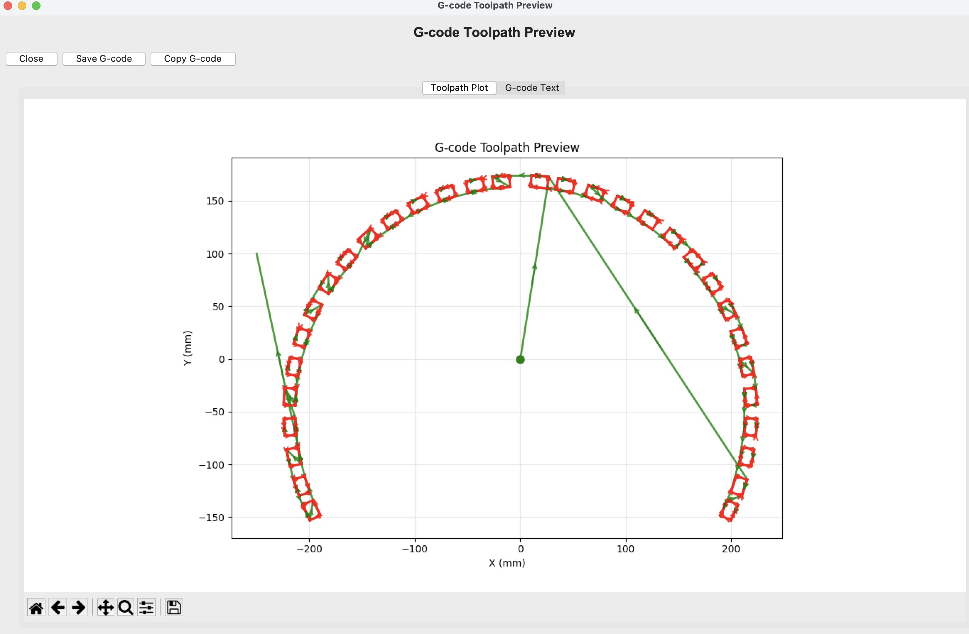

Then click the save G-code button using a name such as “carousel_topcleaning_gcode.nc”. Then close this view to return to the main view; DXF geometry.

Now let’s create the ideal cleaning file for the bottom section. Click the reset all button and then offset the image by 50mm positive in the Y direction, the picture should now look like this:

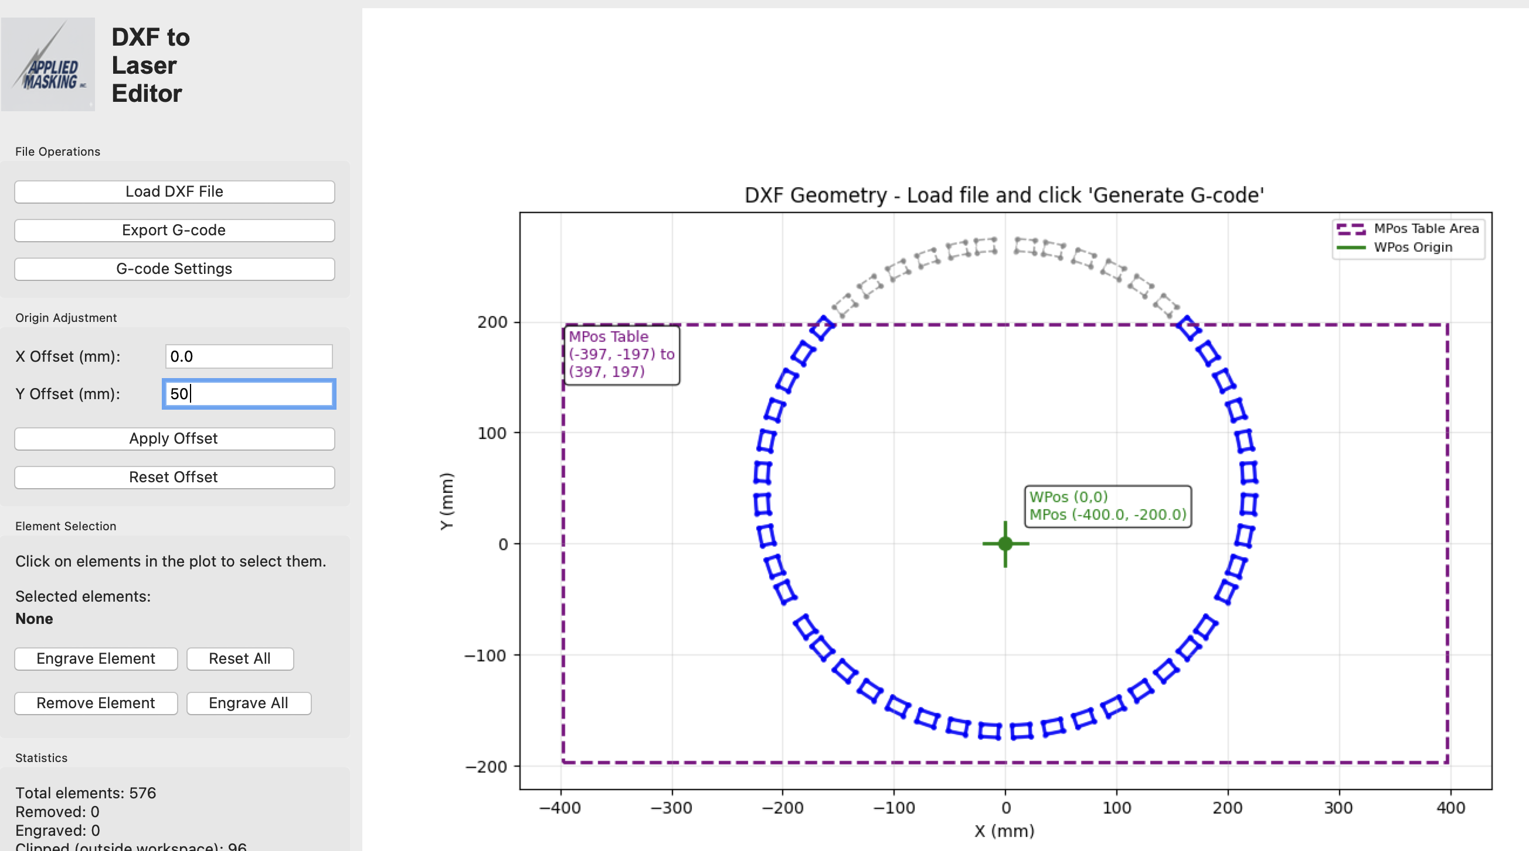

Now select the pads that were not cleaned in the first pass and the select engrave element. The picture should now look like this:

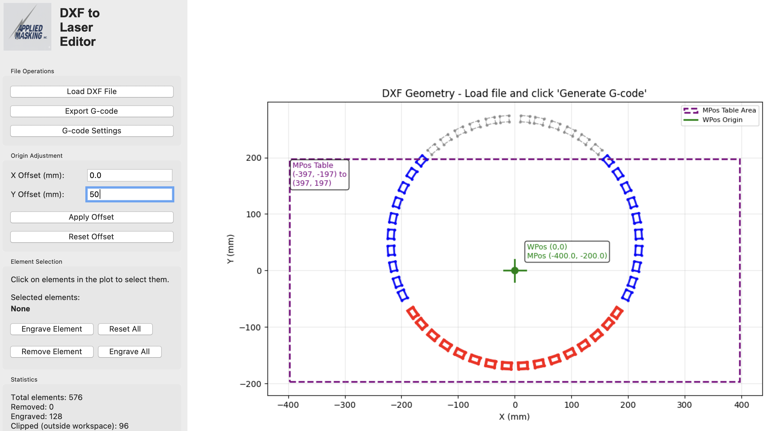

Click the Export G-Code button and save the g-code with a name such as “carousel_bottomcleaning_gcode.nc”.

This concludes the work required to setup for cleaning carousels. The next steps are operations done on each part using the two files that were generated and the two key calibration points:

* carousel_topcleaning_gcode.nc
* carousel_bottomcleaning_gcode.nc
* Left point: -222.959, -22.250 (Section 3 Pad 4)
* Right point: +222.959, -22.250 (Section 1 Pad 13)
* Distance from center: 224.066 mm

# Steps Performed on Each Part

## Calibrating the laser to the part

Each part must be calibrated to align the laser for the upper cleaning and then again for the lower cleaning steps. The process is to set the part on the worktable in the upper or lower position. Then jog the laser, with the target beam on, over to the first target point on the carousel and write the WPOS X and Y coordinates down. Then jog to the 2nd point and write those points down.

With these points accurately captured the G-Code can be adjusted so the laser will align with the carousel part with submillimeter accuracy. It is very important this alignment step be done very accurately. Any errors in the coordinates will result in similar errors in the cleaning path.

For this reason, it may be important to lower the beam focal point to as small as possible to get the resolution needed in positioning.

For this step the laserGRBL is used. The system should be homed, the carousel put into position, the target laser turned on (basically the laser on at very low power), jog the system to the points and record the precise values.

** Note: The steps of Calibration, Adjusting and Cleaning must be performed first for the top of the carousel in that order before moving to the bottom. The carousel must not be moved between the calibration and the cleaning step or the calibration values will be inaccurate.

## Adjusting the G-Code

Another python program is used to adjust the G-Code coordinates to align the laser path to the part. It will prompt for the file name of the ideal G-Code to be adjusted and the coordinates the two targets were found at. First it will calculate the translation and rotation of the carousel part and print that out. It will also flag an estimate of the amount of error in the measurements. If this error is large, it is important to go back a step and remeasure the calibration points.

This output file name will have the word “_adjusted” with a date code on it. This file is intended just to be used once as it is specific to the part currently on the table in the position it is in.

## Cleaning

Use laserGRBL with the adjusted G-Code to clean the top or bottom of the carousel.